Yii Framework 1.1 Validators Cheatsheet
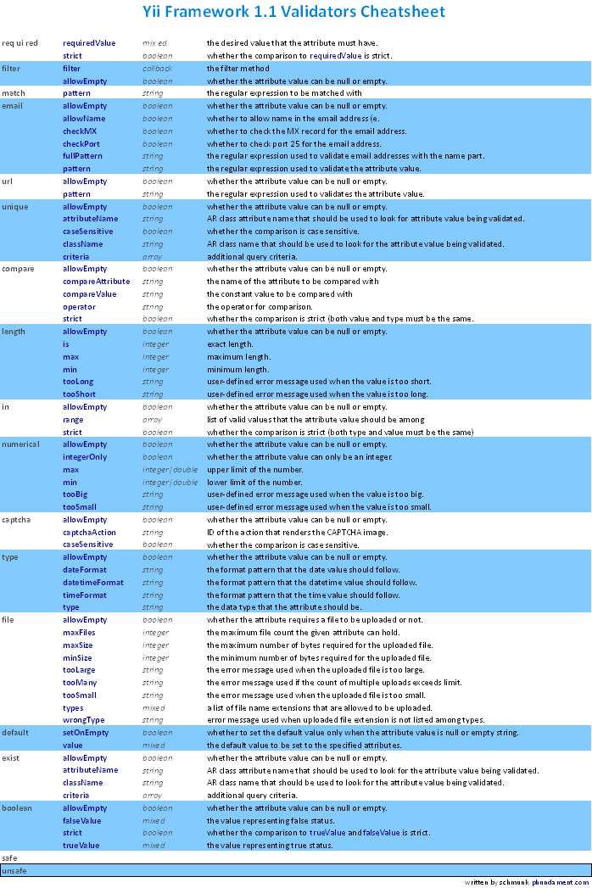
yii-1.1.0-validator-cheatsheet.pdf

