ElementaryOS
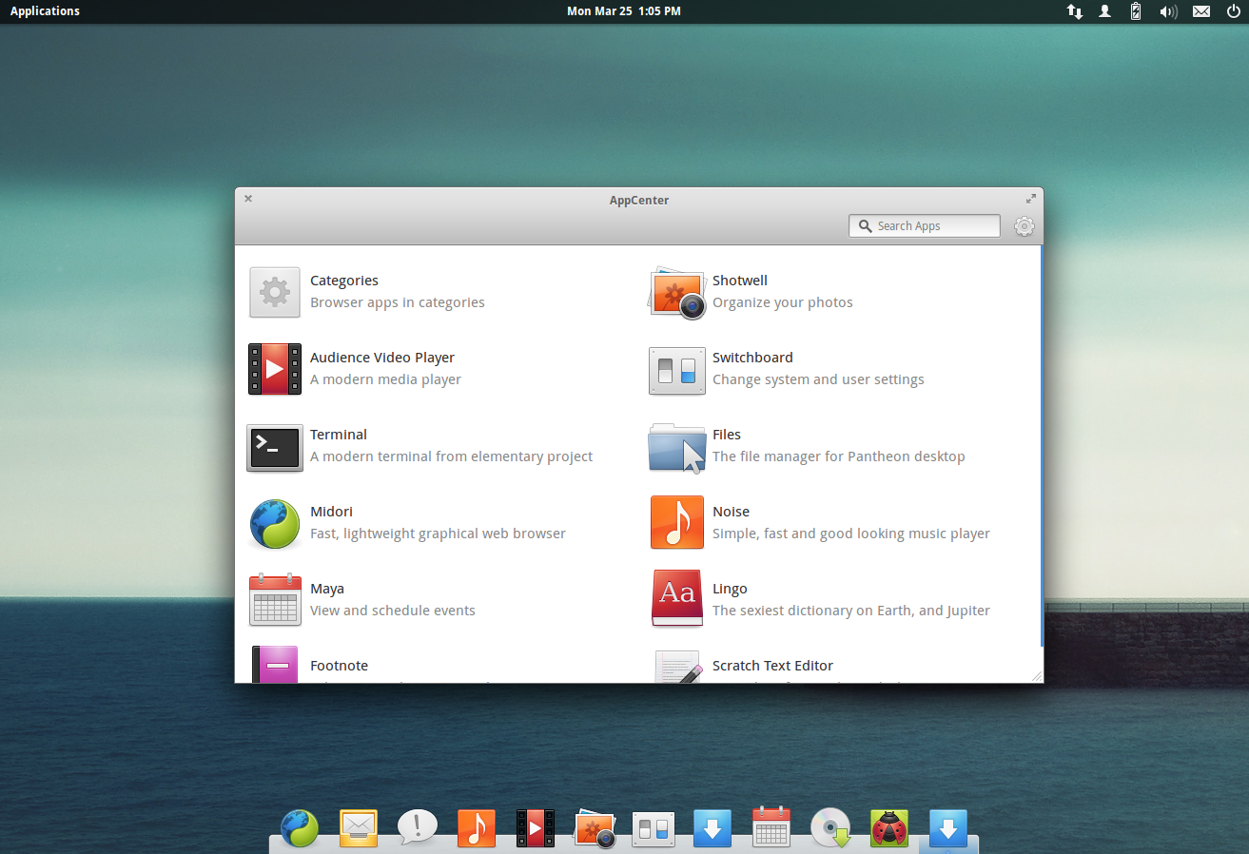
- Pantheon Desktop Environment
- Gala WM - Менеджер окон

Версии
- Freya
- Loki - Текущая, стабильная

Restore boot
- sudo mount /dev/sda2 /mnt
- sudo mount /dev/sda3 /mnt/home
- mount -t proc proc /mnt/proc
- mount -t sysfs sys /mnt/sys
- mount -o bind /dev /mnt/dev
- mount -t devpts pts /mnt/dev/pts/
- cp /etc/resolv.conf /mnt/etc/resolv.conf
- chroot /mnt
- sudo mkdir /boot/efi
- sudo mount /dev/sda1 /boot/efi
- sudo grub-install –target=x86_64-efi –efi-directory=/boot/efi –bootloader-id=ubuntu –recheck
- sudo update-grub
- apt-get install –reinstall grub-efi-amd64
- update-grub

GRUB
- mkfs.vfat -F32 /dev/sda1
- grub-install /dev/sda

Boot UEFI/EFI ESP
linux /boot/vmlinuz-3.13.0-29-generic root=/dev/sda1 initrd /boot/initrd.img-3.13.0-29-generic
- sudo mkdir /boot/efi
- sudo mount /dev/sda2 /boot/efi
- sudo apt-get install grub-efi-amd64
- sudo grub-install /dev/sda
- sudo update-grub

Repaire
- sudo add-apt-repository ppa:yannubuntu/boot-repair
- sudo apt-get update
- sudo apt-get install -y boot-repair && (boot-repair &)

Update
$ sudo apt-get install software-properties-common
$ sudo add-apt-repository --remove ppa:elementary-os/daily
$ sudo add-apt-repository ppa:elementary-os/stable
$ sudo apt-get update
$ sudo apt-get remove elementary-os-prerelease
$ sudo apt-get install --install-recommends linux-generic-lts-xenial xserver-xorg-lts-xenial libgl1-mesa-glx-lts-xenial libegl1-mesa-lts-xenial
$ sudo apt-get dist-upgrade

