iotop
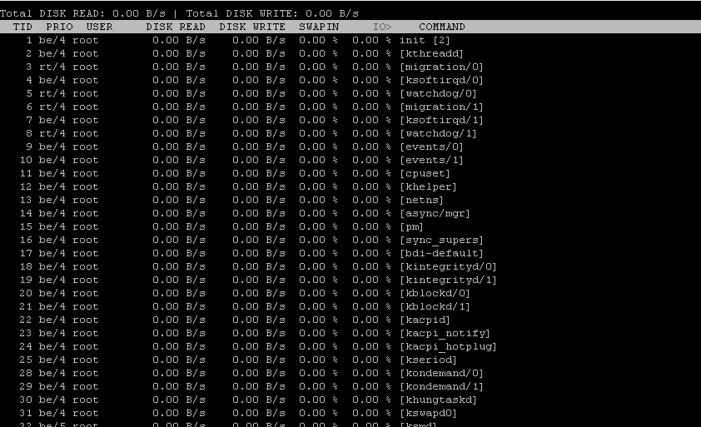
- iotop -b -P -o -d 1
Total DISK READ : 19.57 K/s | Total DISK WRITE : 8.44 M/s
Actual DISK READ: 19.57 K/s | Actual DISK WRITE: 14.10 M/s
PID PRIO USER DISK READ DISK WRITE SWAPIN IO COMMAND
230 be/4 root 0.00 B/s 19.57 K/s 0.00 % 54.53 % [kjournald]
16850 be/4 mysql 19.57 K/s 8.42 M/s 0.00 % 2.84 % mysqld --basedir=/usr --datadir=/var/lib/mysql --plugin-dir=/usr/lib/mysql/plugin --user=mysql --pid-file=/var/run/mysqld/mysqld.pid --socket=/var/run/mysqld/mysqld.sock --port=3306

