ctop
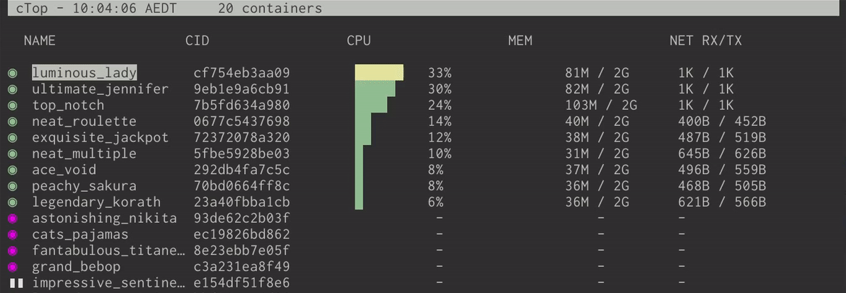
Top-like interface for container metrics
ctop provides a concise and condensed overview of real-time metrics for multiple containers:
$ sudo apt install ca-certificates curl gnupg lsb-release
$ curl -fsSL https://azlux.fr/repo.gpg.key | sudo gpg --dearmor -o /usr/share/keyrings/azlux-archive-keyring.gpg
echo \
"deb [arch=$(dpkg --print-architecture) signed-by=/usr/share/keyrings/azlux-archive-keyring.gpg] http://packages.azlux.fr/debian \
$(lsb_release -cs) main" | sudo tee /etc/apt/sources.list.d/azlux.list >/dev/null
$ sudo apt update
$ sudo apt install docker-ctop

