Proxy

Nginx

GoGatekeeper Proxy

Oauth2 Proxy
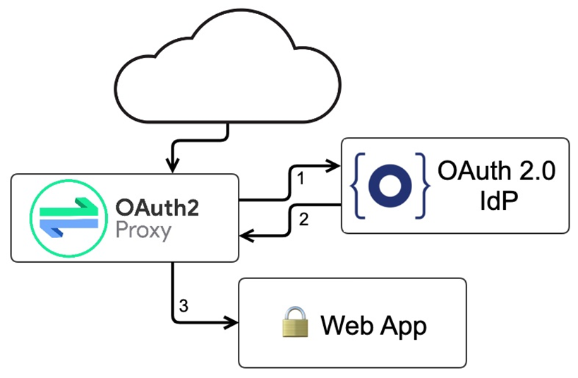

Louketo Proxy

Oathkeeper

Vouch Proxy

