Laravel

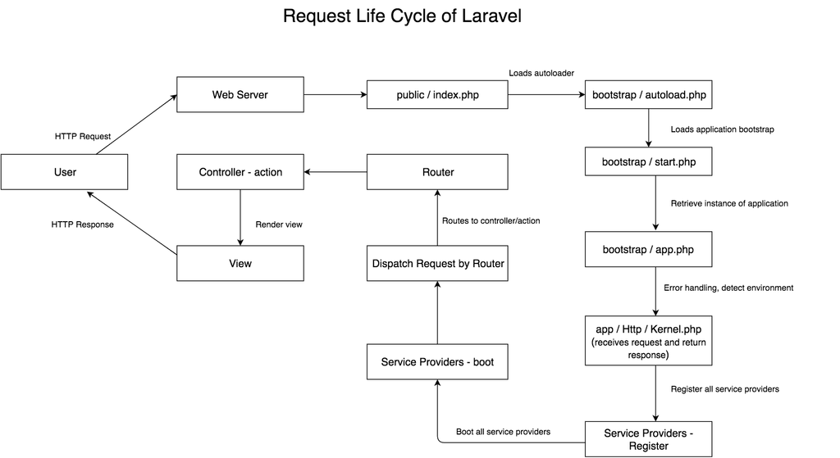

Документация
- http://laravel.su/docs/5.4/installation
- https://laravel.ru/docs/v5/releases
- http://laravel.su/docs/5.4
- https://laravel.com/docs/5.8
- ORM Eloquent
- 20 хитростей в Laravel Eloquent о которых вы не знали

Старт проекта
- composer create-project laravel/laravel ./laravel
- composer create-project –prefer-dist laravel/laravel:^7.0 ./blo
- composer create-project –prefer-dist laravel/laravel ./laravel
- composer create-project laravel/laravel {directory} "5.0.*" –prefer-dist
- composer create-project spatie/package-skeleton-laravel ./

Модули / Расширения
- https://github.com/Askedio/laravel-soft-cascade
- https://github.com/Mirocow/laravel-rabbitmq

Запросы на чтение
$user = User::findOrFail($id);
$user = User::firstOrCreate(['email' => $email]);
$user = User::find(1);
$users = User::find([1,2,3]);
$media = Media::find($id);
$categories = Category::lists('category', 'id');
return view('medias.edit-media')->with('media', $media)->with('categories', $categories);

IN
Game::whereIn('games.id', $roomList)->get();

Column
Game::whereIn('id', $roomList)->pluck('id')->toArray();

Select fields, field
Table::select('name','surname')->where('id', 1)->get();

AsArray
Game::select('games.id as id')->whereIn('games.id', $roomList)->get()->toArray();

NotNull
Model::whereNotNull('sent_at');
DB::table('table_name')->whereNotNull('sent_at')->get();

Scalar
Model::whereNotNull('sent_at');
DB::table('table_name')->where('id' = 1)->get();
$count = App\Flight::where('active', 1)->count();
$max = App\Flight::where('active', 1)->max('price');

Group where
$results = DB::table('table')
->where(function($query) use ($starttime,$endtime){
$query->where('starttime', '<=', $starttime);
$query->where('endtime', '>=', $endtime);
})
->orWhere(function($query) use ($otherStarttime,$otherEndtime){
$query->where('starttime', '<=', $otherStarttime);
$query->where('endtime', '>=', $otherEndtime);
})
->orWhere(function($query) use ($anotherStarttime,$anotherEndtime){
$query->where('starttime', '>=', $anotherStarttime);
$query->where('endtime', '<=', $anotherEndtime);
})
->get();

Sub query
$sub = Abc::where(..)->groupBy(..); // Eloquent Builder instance
$count = DB::table( DB::raw("({$sub->toSql()}) as sub") )
// ->where(..) wrong
->mergeBindings($sub->getQuery()) // you need to get underlying Query Builder
// ->where(..) correct
->count();
DB::query()->fromSub(function ($query) {
$query->from('abc')->groupBy('col1');
}, 'a')->count();

Запросы на добавление/обновление
$friend = Friend::updateOrCreate(
['user_id' => $friendId, 'friend_id' => $userId],
['status' => Friend::STATUS_ACCEPTED]
);
# https://laravel.com/docs/5.3/eloquent#inserting-and-updating-models

Update all
YourModelName::where(['siteView' => 6])->update(['siteView' => 7]);
YourModelName::where('siteView', 6)->update(['siteView' => 7]);
YourModelName::query()->update(['siteView' => 8]);

Заполнение/обновление/проверка пивот таблиц
$room->games()->attach($gameId);
$owner->rooms()->attach($room->id, ['is_admin' => true]);
$user->roles()->updateExistingPivot($roleId, $attributes);
$post->comments()->saveMany([
new App\Comment(['message' => 'A new comment.']),
new App\Comment(['message' => 'Another comment.']),
]);
$user->roles()->attach($roleId);
$user->roles()->attach($roleId, [‘expires’ => $expires]);
App\User::find(1)->roles()->save($role, ['expires' => $expires]);
$user->roles()->toggle([1, 2, 3]);
$messages = Message::where('message_id', $id)->get();
foreach($messages as $message) {
$message->users()->updateExistingPivot($user, array('status' => 1), false);
}
$items = $invoice->items->pluck('name', 'id')->toArray();
foreach ($items as $key => $item) {
$invoice->items()->updateExistingPivot($key, ['quantity' => $request->quantity]);
}
$user->rooms()->get()->contains($room->id)

Increment
$article = Article::find($article_id);
$article->increment('read_count');
Article::find($article_id)->increment('read_count');
Article::find($article_id)->increment('read_count', 10); // +10
Product::find($produce_id)->decrement('stock'); // -1

Запросы на удаление
$ids = array(10, 20, 30);
DB::table('table_name')->whereIn('id', $ids)->delete();
MyModel::truncate();
\App\Model::query()->delete();
DB::statement("SET foreign_key_checks=0");
Model::truncate();
DB::statement("SET foreign_key_checks=1");
DB::table('table_name')->truncate();
DB::table('table_name')->delete();
Model::whereRaw('1=1')->delete();
User:where('id', 'like' '%%')->delete();
DB::table('users')->whereIn('id', $ids_to_delete)->delete();

Transactions
app('db')->beginTransaction();
app('db')->commit();
app('db')->rollBack();

