NFQWS
https://github.com/bol-van/zapret
$ ./install_easy.sh
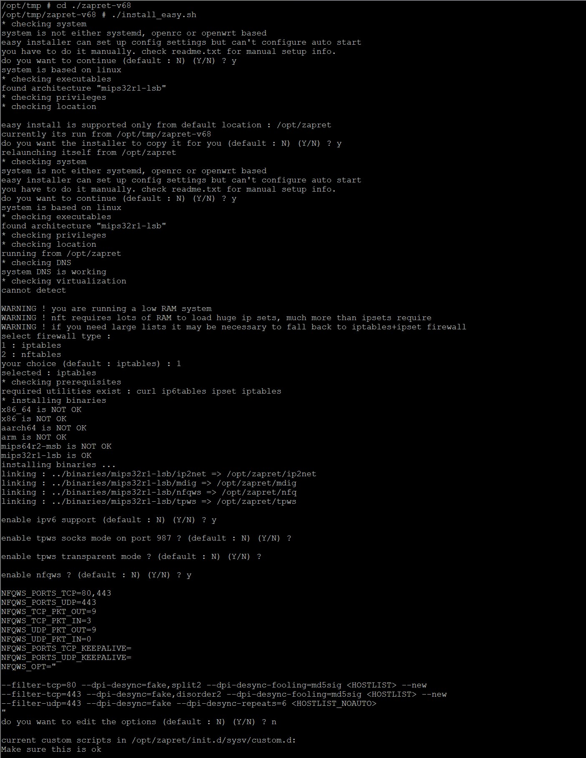
Выбираем имя внутреннего сетевого интерфейса (LAN), br0 - обычно в роутере:
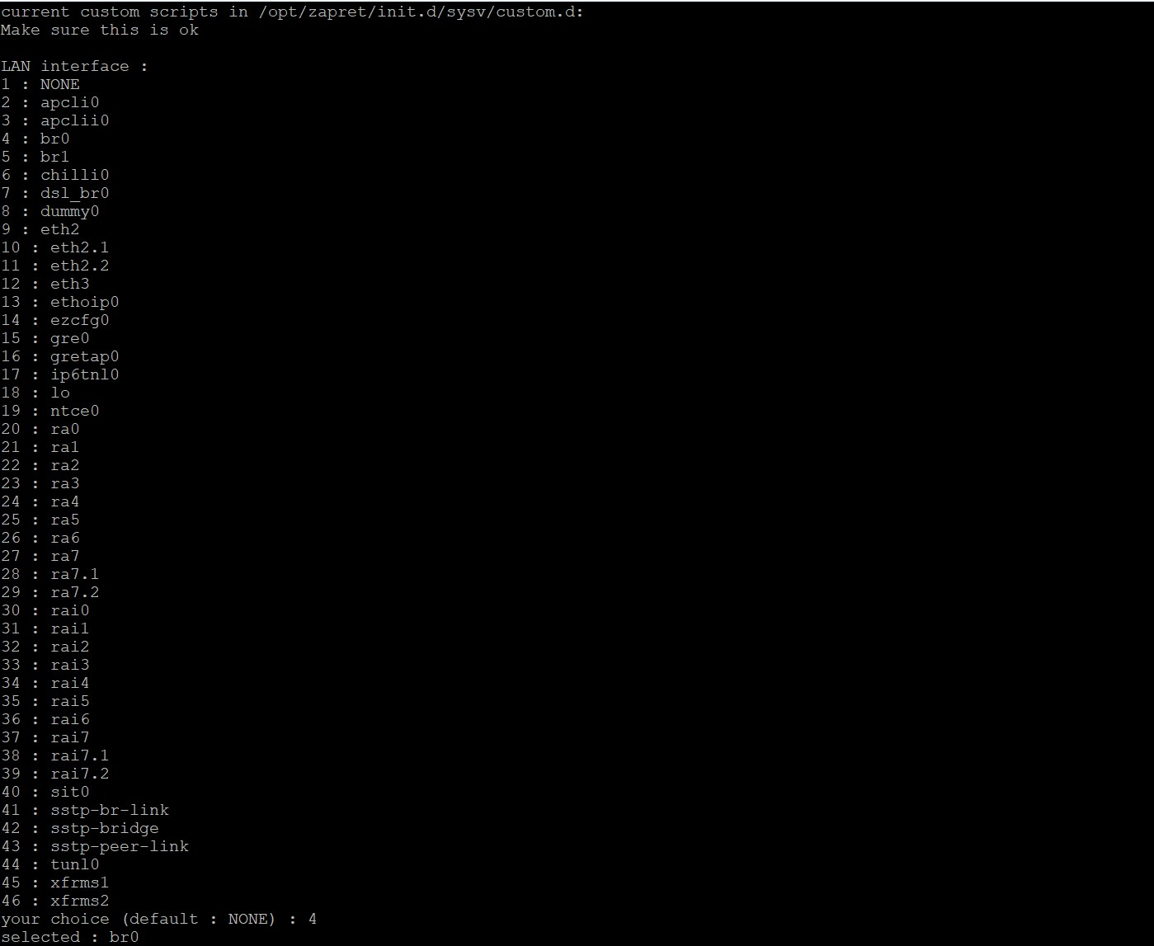
Но заворот трафика на nfqws происходит всегда после маршрутизации, поэтому к нему применима только фильтрация по WAN, так что LAN в этом режиме работы неважен.
Важно: выбираем режим фильтрации трафика (none, ipset, hostlist, autohostlist).
- none - фильтрация отключена, весь трафик обрабатывается утилитой. Простейший вариант. Рекомендую его использовать, если не хотите заморачиваться настройкой списков адресов, а хотите просто, чтобы быстро и просто все работало.
- ipset - фильтрация трафика с помощью ipset. Сложный режим, как работает читаем в инструкции.
- hostlist - фильтрация списком хостов из файлов: /opt/zapret/ipset/zapret-hosts-user.txt - прописывайте свои домены, которые нужно обрабатывать или в файле/opt/zapret/ipset/zapret-hosts-user-exclude.txt - домены, которые нужно исключить из обработки. Пишется по одному доменному имени или IP-адресу на строчку. То что там изначально написано в файлах - удаляем. Рекомендую это режим использовать, если хотите обрабатывать только определенные адреса или наоборот если хотите исключить из обработки некоторые адреса.
- autohostlist -режим hostlist + распознавание блокировок и ведение автоматического листа.
Режим фильтра также можно потом менять через параметр MODE_FILTER в /opt/zapret/config.
nano /opt/zapret/ipset/zapret-hosts-user.txt
www.youtube.com
youtube.com
nano /opt/zapret/init.d/sysv/zapret
#!/bin/sh
### BEGIN INIT INFO
# Provides: zapret
# Required-Start: $local_fs $network
# Required-Stop: $local_fs $network
# Default-Start: 2 3 4 5
# Default-Stop: 0 1 6
### END INIT INFO
SCRIPT=$(readlink -f "$0")
EXEDIR=$(dirname "$SCRIPT")
ZAPRET_BASE=$(readlink -f "$EXEDIR/../..")
. "$EXEDIR/functions"
NAME=zapret
DESC=anti-zapret
do_start()
{
if lsmod | grep "xt_multiport " &> /dev/null ; then
echo "xt_multiport.ko is already loaded"
else
if insmod /lib/modules/$(uname -r)/xt_multiport.ko &> /dev/null; then
echo "iptable_raw.ko loaded"
else
echo "Cannot find xt_multiport.ko kernel module, aborting"
#exit 1
fi
fi
if lsmod | grep "xt_connbytes " &> /dev/null ; then
echo "xt_connbytes.ko is already loaded"
else
if insmod /lib/modules/$(uname -r)/xt_connbytes.ko &> /dev/null; then
echo "xt_connbytes.ko loaded"
else
echo "Cannot find xt_connbytes.ko kernel module, aborting"
#exit 1
fi
fi
if lsmod | grep "xt_NFQUEUE " &> /dev/null ; then
echo "xt_NFQUEUE.ko is already loaded"
else
if insmod /lib/modules/$(uname -r)/xt_NFQUEUE.ko &> /dev/null; then
echo "xt_NFQUEUE.ko loaded"
else
echo "Cannot find xt_NFQUEUE.ko kernel module, aborting"
#exit 1
fi
fi
zapret_run_daemons
[ "$INIT_APPLY_FW" != "1" ] || { zapret_apply_firewall; }
}
do_stop()
{
zapret_stop_daemons
[ "$INIT_APPLY_FW" != "1" ] || zapret_unapply_firewall
}
case "$1" in
start)
do_start
;;
stop)
do_stop
;;
restart)
do_stop
do_start
;;
start-fw|start_fw)
zapret_apply_firewall
;;
stop-fw|stop_fw)
zapret_unapply_firewall
;;
restart-fw|restart_fw)
zapret_unapply_firewall
zapret_apply_firewall
;;
start-daemons|start_daemons)
zapret_run_daemons
;;
stop-daemons|stop_daemons)
zapret_stop_daemons
;;
restart-daemons|restart_daemons)
zapret_stop_daemons
zapret_run_daemons
;;
reload-ifsets|reload_ifsets)
zapret_reload_ifsets
;;
list-ifsets|list_ifsets)
zapret_list_ifsets
;;
list-table|list_table)
zapret_list_table
;;
*)
N=/etc/init.d/$NAME
echo "Usage: $N {start|stop|restart|start-fw|stop-fw|restart-fw|start-daemons|stop-daemons|restart-daemons|reload-ifsets|list-ifsets|list-table}" >&2
exit 1
;;
esac
exit 0
nano /opt/zapret/config
# this file is included from init scripts
# change values here
# can help in case /tmp has not enough space
#TMPDIR=/opt/zapret/tmp
# redefine user for zapret daemons. required on Keenetic
WS_USER=nobody
# override firewall type : iptables,nftables,ipfw
FWTYPE=iptables
# nftables only : set this to 0 to use pre-nat mode. default is post-nat.
# pre-nat mode disables some bypass techniques for forwarded traffic but allows to see client IP addresses in debug log
#POSTNAT=0
# options for ipsets
# maximum number of elements in sets. also used for nft sets
SET_MAXELEM=522288
# too low hashsize can cause memory allocation errors on low RAM systems , even if RAM is enough
# too large hashsize will waste lots of RAM
IPSET_OPT="hashsize 262144 maxelem $SET_MAXELEM"
# dynamically generate additional ip. $1 = ipset/nfset/table name
#IPSET_HOOK="/etc/zapret.ipset.hook"
# options for ip2net. "-4" or "-6" auto added by ipset create script
IP2NET_OPT4="--prefix-length=22-30 --v4-threshold=3/4"
IP2NET_OPT6="--prefix-length=56-64 --v6-threshold=5"
# options for auto hostlist
AUTOHOSTLIST_RETRANS_THRESHOLD=3
AUTOHOSTLIST_FAIL_THRESHOLD=3
AUTOHOSTLIST_FAIL_TIME=60
# 1 = debug autohostlist positives to ipset/zapret-hosts-auto-debug.log
AUTOHOSTLIST_DEBUGLOG=0
# number of parallel threads for domain list resolves
MDIG_THREADS=30
# ipset/*.sh can compress large lists
GZIP_LISTS=1
# command to reload ip/host lists after update
# comment or leave empty for auto backend selection : ipset or ipfw if present
# on BSD systems with PF no auto reloading happens. you must provide your own command
# set to "-" to disable reload
#LISTS_RELOAD="pfctl -f /etc/pf.conf"
# mark bit used by nfqws to prevent loop
DESYNC_MARK=0x40000000
DESYNC_MARK_POSTNAT=0x20000000
TPWS_SOCKS_ENABLE=0
# tpws socks listens on this port on localhost and LAN interfaces
TPPORT_SOCKS=987
# use <HOSTLIST> and <HOSTLIST_NOAUTO> placeholders to engage standard hostlists and autohostlist in ipset dir
# hostlist markers are replaced to empty string if MODE_FILTER does not satisfy
# <HOSTLIST_NOAUTO> appends ipset/zapret-hosts-auto.txt as normal list
TPWS_SOCKS_OPT="
--filter-tcp=80 --methodeol <HOSTLIST> --new
--filter-tcp=443 --split-pos=1,midsld --disorder <HOSTLIST>
"
TPWS_ENABLE=0
TPWS_PORTS=80,443
# use <HOSTLIST> and <HOSTLIST_NOAUTO> placeholders to engage standard hostlists and autohostlist in ipset dir
# hostlist markers are replaced to empty string if MODE_FILTER does not satisfy
# <HOSTLIST_NOAUTO> appends ipset/zapret-hosts-auto.txt as normal list
TPWS_OPT="
--filter-tcp=80 --methodeol <HOSTLIST> --new
--filter-tcp=443 --split-pos=1,midsld --disorder <HOSTLIST>
"
NFQWS_ENABLE=1
# redirect outgoing traffic with connbytes limiter applied in both directions.
NFQWS_PORTS_TCP=80,443
NFQWS_PORTS_UDP=443
# PKT_OUT means connbytes dir original
# PKT_IN means connbytes dir reply
# this is --dpi-desync-cutoff=nX kernel mode implementation for linux. it saves a lot of CPU.
NFQWS_TCP_PKT_OUT=$((6+$AUTOHOSTLIST_RETRANS_THRESHOLD))
NFQWS_TCP_PKT_IN=3
NFQWS_UDP_PKT_OUT=$((6+$AUTOHOSTLIST_RETRANS_THRESHOLD))
NFQWS_UDP_PKT_IN=0
# redirect outgoing traffic without connbytes limiter and incoming with connbytes limiter
# normally it's needed only for stateless DPI that matches every packet in a single TCP session
# typical example are plain HTTP keep alives
# this mode can be very CPU consuming. enable with care !
#NFQWS_PORTS_TCP_KEEPALIVE=80
#NFQWS_PORTS_UDP_KEEPALIVE=
# use <HOSTLIST> and <HOSTLIST_NOAUTO> placeholders to engage standard hostlists and autohostlist in ipset dir
# hostlist markers are replaced to empty string if MODE_FILTER does not satisfy
# <HOSTLIST_NOAUTO> appends ipset/zapret-hosts-auto.txt as normal list
NFQWS_OPT="
--filter-tcp=80 --dpi-desync=fake,multisplit --dpi-desync-ttl=0 --dpi-desync-fooling=md5sig,badsum <HOSTLIST> --new
--filter-tcp=443 --dpi-desync=fake,multidisorder --dpi-desync-split-pos=method+2,midsld,5 --dpi-desync-ttl=0 --dpi-desync-fooling=md5sig,badsum,badseq --dpi-desync-repeats=15 --dpi-desync-fake-tls=/opt/zapret/files/fake/tls_clienthello_www_google_com.bin <HOSTLIST> --new
--filter-udp=443 --dpi-desync=fake --dpi-desync-repeats=15 --dpi-desync-ttl=0 --dpi-desync-any-protocol --dpi-desync-cutoff=d4 --dpi-desync-fooling=md5sig,badsum --dpi-desync-fake-quic=/opt/zapret/files/fake/quic_initial_www_google_com.bin <HOSTLIST>
"
# none,ipset,hostlist,autohostlist
MODE_FILTER=none
# openwrt only : donttouch,none,software,hardware
FLOWOFFLOAD=donttouch
# openwrt: specify networks to be treated as LAN. default is "lan"
#OPENWRT_LAN="lan lan2 lan3"
# openwrt: specify networks to be treated as WAN. default wans are interfaces with default route
#OPENWRT_WAN4="wan vpn"
#OPENWRT_WAN6="wan6 vpn6"
# for routers based on desktop linux and macos. has no effect in openwrt.
# CHOOSE LAN and optinally WAN/WAN6 NETWORK INTERFACES
# or leave them commented if its not router
# it's possible to specify multiple interfaces like this : IFACE_LAN="eth0 eth1 eth2"
# if IFACE_WAN6 is not defined it take the value of IFACE_WAN
IFACE_LAN=br0
IFACE_WAN=eth3
#IFACE_WAN6="ipsec0 wireguard0 he_net"
# should start/stop command of init scripts apply firewall rules ?
# not applicable to openwrt with firewall3+iptables
INIT_APPLY_FW=1
# firewall apply hooks
#INIT_FW_PRE_UP_HOOK="/etc/firewall.zapret.hook.pre_up"
#INIT_FW_POST_UP_HOOK="/etc/firewall.zapret.hook.post_up"
#INIT_FW_PRE_DOWN_HOOK="/etc/firewall.zapret.hook.pre_down"
#INIT_FW_POST_DOWN_HOOK="/etc/firewall.zapret.hook.post_down"
# do not work with ipv4
#DISABLE_IPV4=1
# do not work with ipv6
DISABLE_IPV6=0
# select which init script will be used to get ip or host list
# possible values : get_user.sh get_antizapret.sh get_combined.sh get_reestr.sh get_hostlist.sh
# comment if not required
#GETLIST

