Mytop
mytop is a console-based (non-gui) tool for monitoring the threads and overall performance of a MySQL 3.22.x, 3.23.x, and 4.x server. It runs on most Unix systems (including Mac OS X) which have Perl, DBI, and Term::ReadKey installed. And with Term::ANSIColor installed you even get color. If you install Time::HiRes, you'll get good real-time queries/second stats. As of version 0.7, it even runs on Windows (somewhat).

Установка
$ wget http://jeremy.zawodny.com/mysql/mytop/mytop-1.6.tar.gz
$ tar xvfz mytop-1.6.tar.gz
$ cpan install Config::IniFiles

Использование
Мониторнг базы данных MySQL или MariaDB
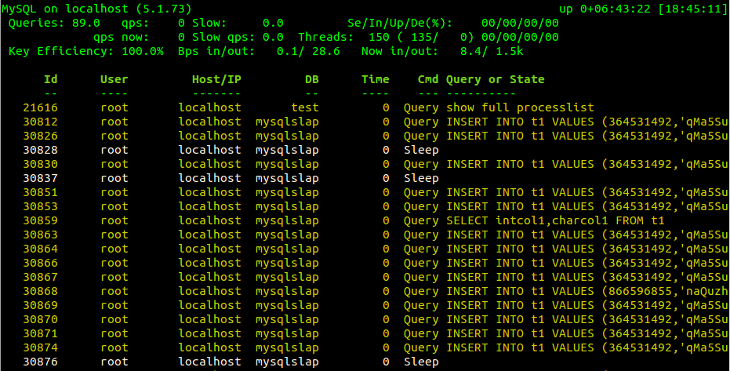
- mytop -u root -p password
- mytop -S /var/run/mysqld/mysqld.sock -u root -p password -s 1

Пользовательските настройки
nano ~/.mytop
user=root
pass=password
host=localhost
delay=5
port=3306
socket=
batchmode=0
header=1
color=1
idle=1

Debian
mytop -S /var/run/mysqld/mysqld.sock -u debian-sys-maint -p $(cat /etc/mysql/debian.cnf|grep password|sed 's/password = //'|head -n 1) -s 1

